PDC
Creating Charge Offer
1. Product creation using GUI
Step1: create work space by clicking on + symbol
Step2: click on create charge offer
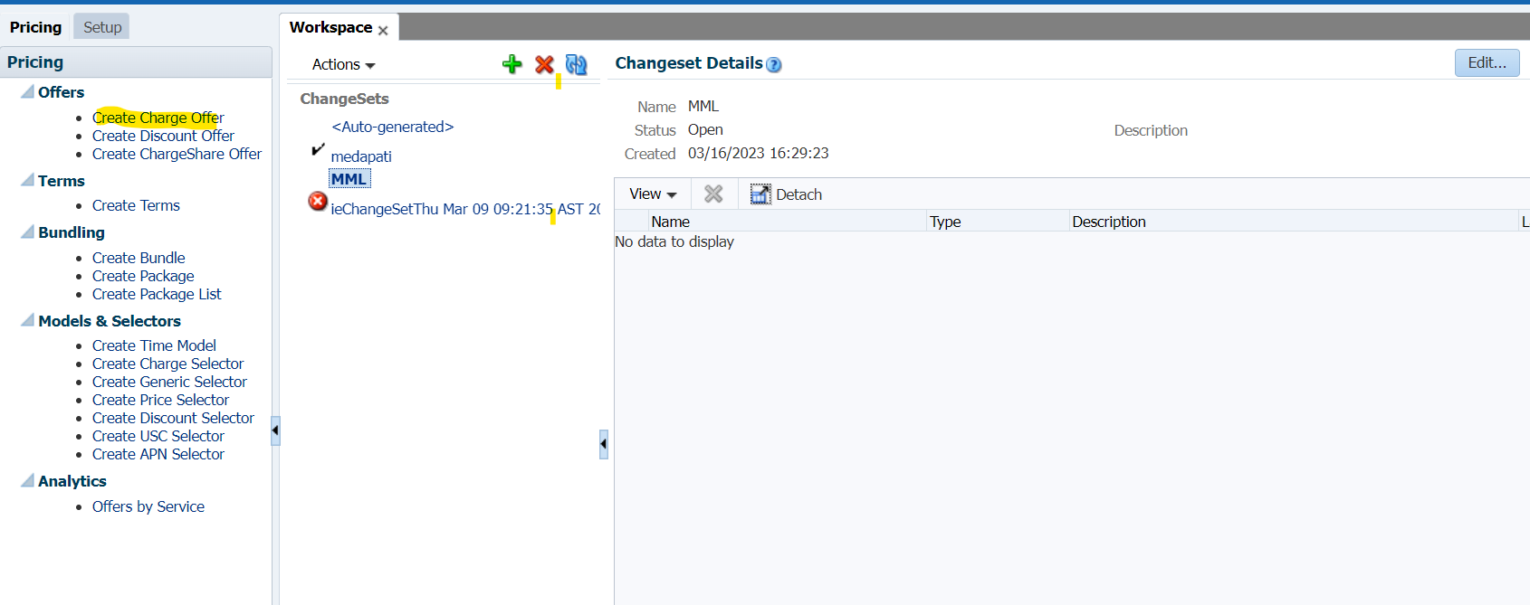

Step3: Product name ( unique name - the box will appear in red color if you enter already existed name)
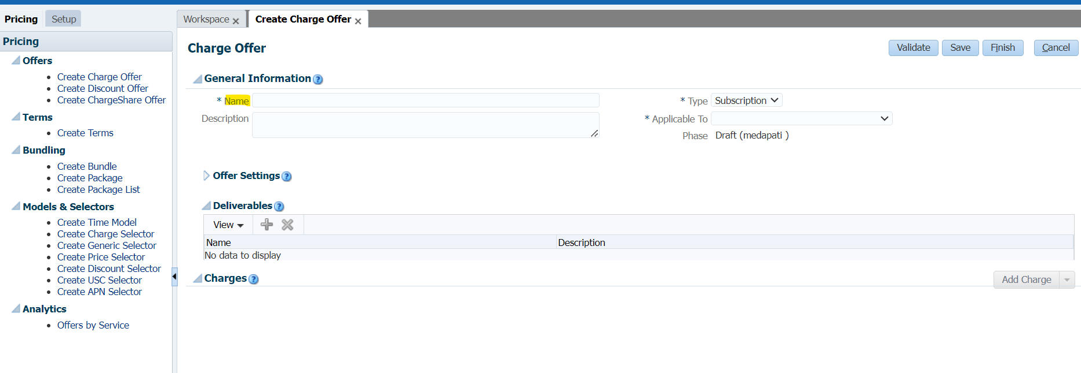
Step4: Product description
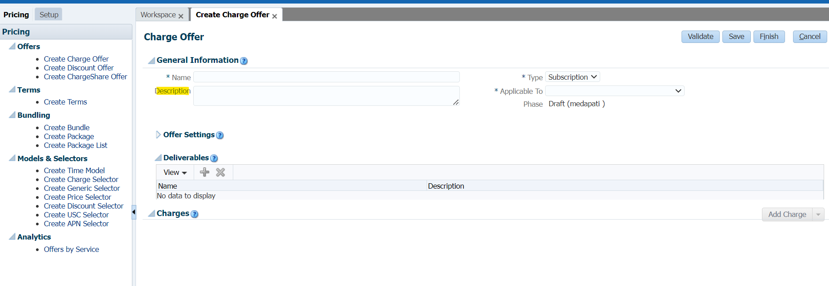
Step5: Type
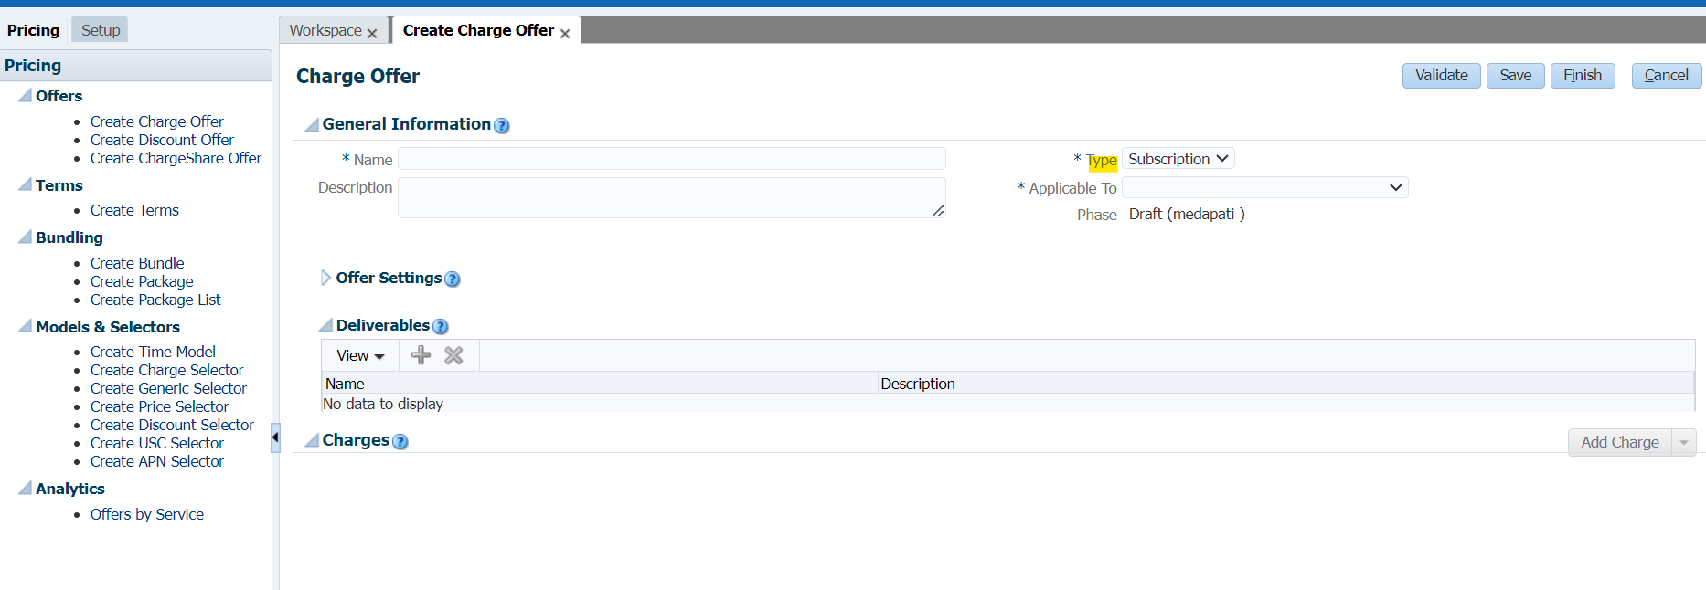
Step6: Service type - ( will check in next session how we can add new service type in UI)
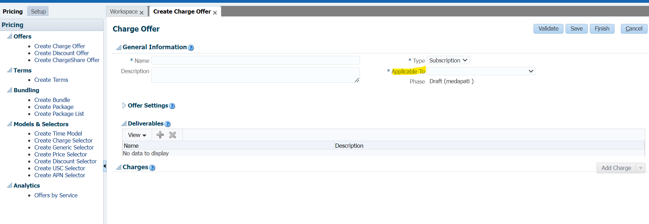
Step7: Click on ADD Charge then click on ADD new charge
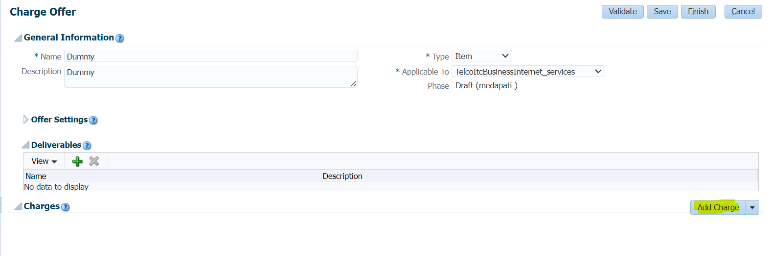
MRC or NRC product
MRC event type - forward_monthly_cycle
NRC event type - product fee purchase
Step8: MRC- subscription
MRC event type - forward_monthly_cycle
NRC- Item
NRC event type - product fee purchase
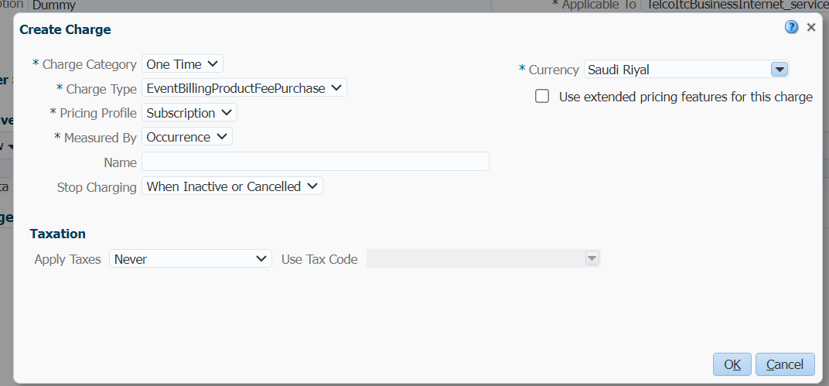
Step9: Create charge- name will be like product_name_Charge
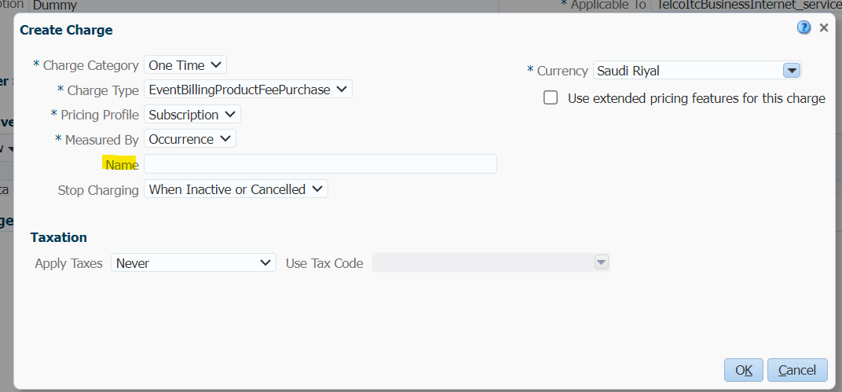
Step10: Apply taxes
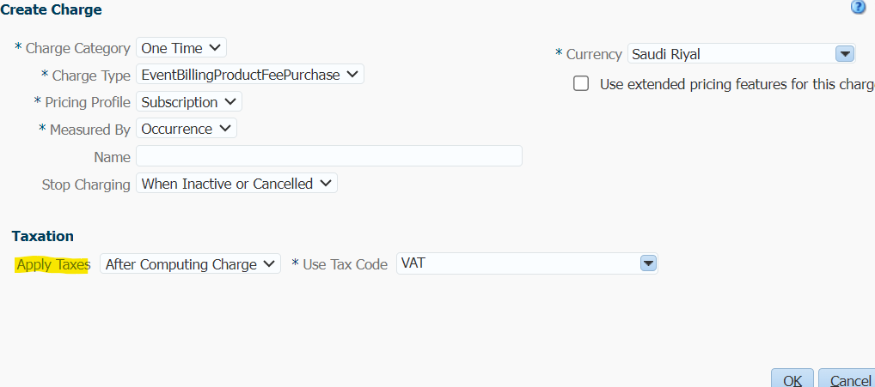
Step11: choose GL_ID (GL_ID - If GL_ID is there we can add as per requirement else we can keep it as null)
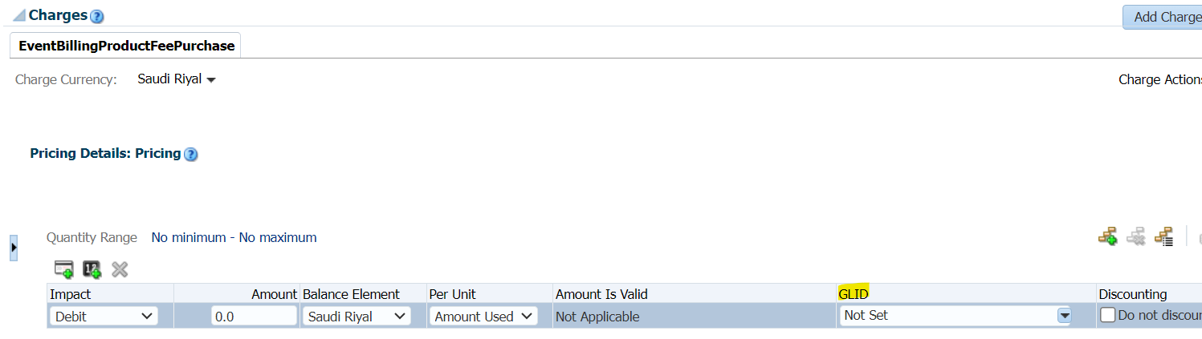
Step12: validate
Step13. if no errors click finish
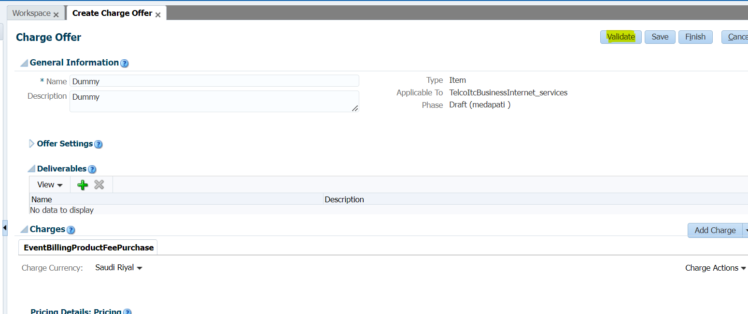
Step14: go to workspace, you can see the product which was created, click on submit.
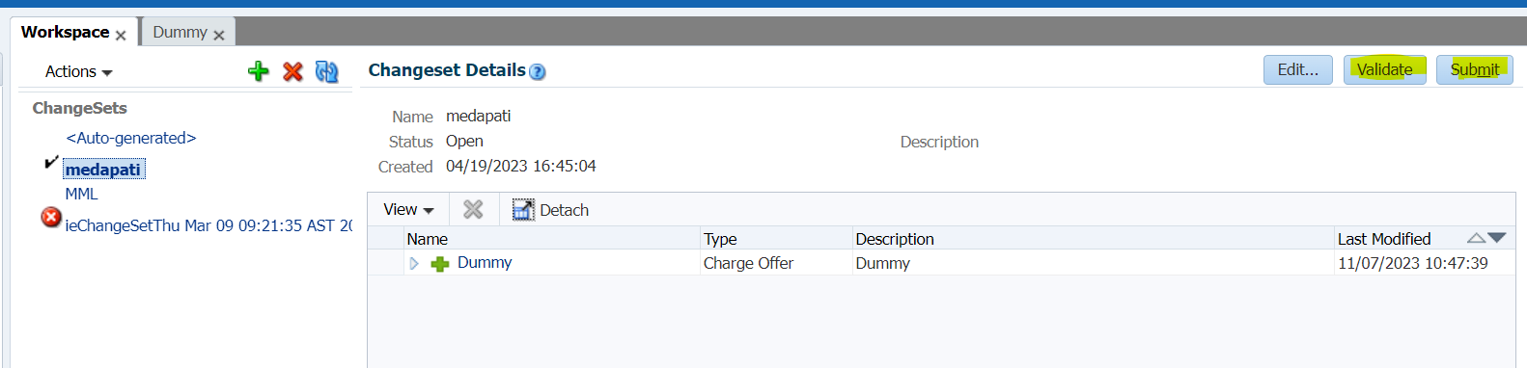
Step15: go to database and check for the product under product_t table whether product is created or not.
2. Product creation using xml
Step1: moving product from dev env to sit
cd $PDC_Home
Step2: create directory with our name
Step3: importing and exporting product using xml take product name from DB
for example product name : dummy123
do export command in dev
ImportExportPricing -export DUMMY_Product -pricing -n 'DUMMY123' -expRefs < password.txt
DUMMY_Product.xml will generates
Step4: move xml from DEV to SIT
then use import command in SIT
ImportExportPricing -import -pricing DUMMY_Product.xml -ignoreID -ow < password.txt
then check the entries in product_t and aq_sync tables
if we want move the same product then we need to change the description with dot like that..then do import and check the xml
then do export in same env to save the changes and to sync product (if no need to sync then no need export after changes done)
check the entries in product_t and aq_sync tables with descr (ex:dummy123.)
if you want to sync the product with CRM please enable the dequeue else delete the entry from aq_sync table.
please do commit after deletion.

3. Product synching
before going to the path please check both RRE and SyncPDC is up and running
ps -ef | grep RRE
ps -ef | grep SyncPDC
BRM -> PDC - will configure services from BRM to PDC
Go to the path: cd /app/PricingDCIntegration/PDC_BRM/apps/bin
do the below commands
nohup ./RRETransformer < password & (nohup means - no hangup)
nohup ./startSyncPDC < password &
check PDC is up and running - ps -ef | grep SyncPDC

4. Service class extension:
Step1: Log into the Server
path : /app/BRM/opt/portal/12.0/BRM/sys/test/ABC/Billing_automation
dummy_rental.podl
dummy_onetime.podl
dummy_service.podl
Step2: take these three files and add new service
use below commands to deploy the podl
pin_deploy create dummy123_service.podl - for new service use create
pin_deploy replace dummy123_service.podl - if any changes done in existing one
Step3: restart SyncPDC
Step4: go to PDCUI
goto setup
select service event map
click on new + symbol
it will ask for service - we can select the service which was created by us and select event types.
click on service name and then click on +
then choose cycle forward monthly and purchase fee
Step5: click on save and go to workspace and validate and submit
Step6: After the service extension verify under table using below queries
select * from dd_objects_t where name like '/service/%';
select * from dd_objects_t where name like '/item/%';
5. configuration of GL_ID
Step1: Goto PDC server
path:/app/BRM/opt/portal/12.0/BRM/sys/data/pricing/example
pin_glid
Step2: Go to glid section and add glid and descr is same as name, we need to change glid number in 6 places others are same then save the file.
Step3: give the command: load_pin_glid itc_pin_glid -verbose (to load glid).
Step4: restart cm and dm
Step5: Go to PDC UI
Click on glid dropdown and check whether new glid is added or not.

